CLC --- SPACE Matrix, Grand Matrix, and Quantitative Strategic Planning Matrix

Red Group

CLC --- SPACE Matrix, Grand Matrix, and Quantitative Strategic Planning Matrix
Part 1: SPACE Matrix
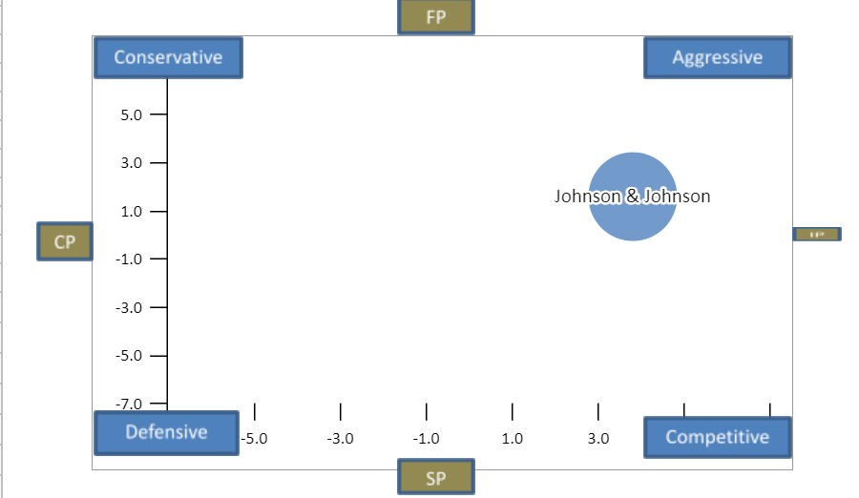
 | Johnson & Johnson
X Axis | 3.8 | 0.0 | 0.0
Y Axis | 1.6 | 0.0 | 0.0
Internal Analysis: |  |  |  |  |  |  |  | External Analysis:
Financial Position (FP) |  |  |  |  |  |  |  | Stability Position (SP)
Current Ratio |  |  |  |  |  |  | 7 | Rate of Inflation |  |  |  | -3
Debt to Equity |  |  |  |  |  |  | 3 | Technological Changes |  |  |  | -1
Net Income |  |  |  |  |  |  | 5 | Price Elasticity of Demand |  |  |  | -3
Revenue |  |  |  |  |  |  | 7 | Competitive Pressure |  |  |  | -4
Inventory Turnover |  |  |  |  |  |  | 4 | Barriers to Entry into Market |  |  |  | -7
Financial Position (FP) Average |  |  |  |  |  |  | 5.2 | Stability Position (SP) Average |  |  |  | -3.6
Internal Analysis: |  |  |  |  |  |  |  | External Analysis:
Competitive Position (CP) |  |  |  |  |  |  |  | Industry Position (IP)
Market Share |  |  |  |  |  |  | -1 | Growth Potential |  |  |  | 7
Product Quality |  |  |  |  |  |  | -1 | Financial Stability |  |  |  | 6
Customer Loyalty |  |  |  |  |  |  | -2 | Ease of Entry into Market |  |  |  | 4
Variety of Products Offered |  |  |  |  |  |  | -1 | Resource Utilization |  |  |  | 5
Control over Suppliers and Distributors |  |  |  |  |  |  | -3 | Profit Potential |  |  |  | 5
Competitive Position (CP) Average |  |  |  |  |  |  | -1.6 | Industry Position (IP) Average |  |  |  | 5.4

Recommendations from the space analysis
Johnson's and Johnson's company has been a renowned pharmaceutical company. However, there are one evidential. the problem that sees cause the company to be at an unbalance with relations to its financial ratios. From the Space analysis identified through the Financial Ratio Analysis and Internal Factors Evaluation matrix, some amicable resolution can be drawn for the company to implement (David & David, 2020).
The analysis identifies market penetration and research as the key problems facing the company. With regards to the market penetration issue, it is relevant that the company should dig deeper into the markets dynamics and relevant factors that contribute to the company's product attaining a good competitive advantage in the market. This can be achieved through seeking cheap resources of similar quality with the current resources to sustain the cost of production and enable revision of market prices.
The research and development need to advance to ensure the sustainability of the company and at the same time ensure customer satisfaction. This will require research into other means of production that will be needless to provide quality pharmaceutical products. Here the company will be able to retain its customers and at the same time compete healthily with its competitors such as Pfizer and Merck.

Part 2: Grand Matrix
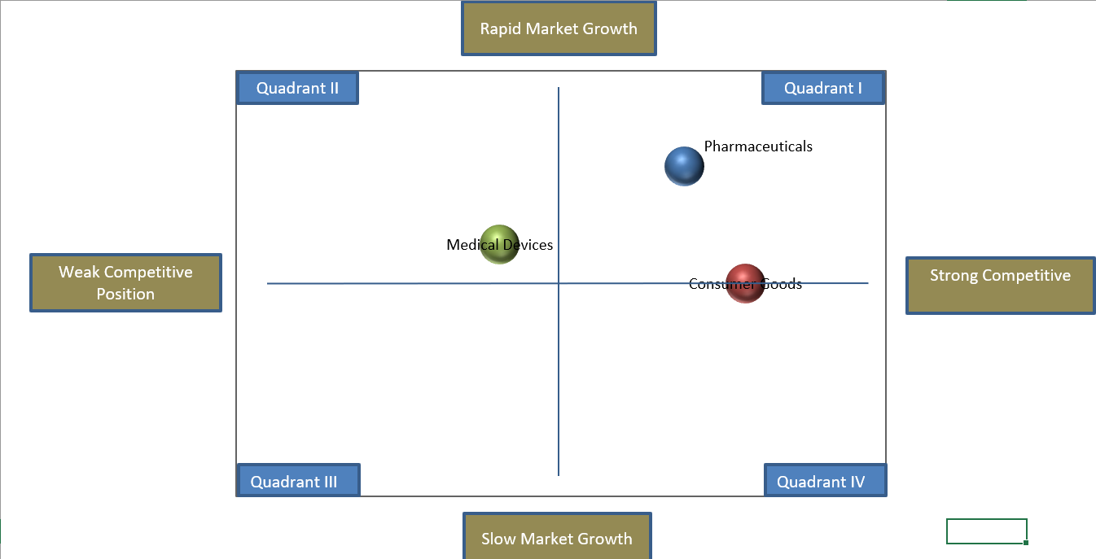

Part 3: Quantitative Strategic Planning Matrix
 |  |  | Invest in R&D to increase the growth in equipments and assets that are currently in place to generate more revenue with compitetors in the market place |  | Create a new products in that do not require strict govement regulations to generate generic products. This will help the organization regain consumer confidence back
 | Strengths | Weight | AS | TAS | AS | TAS
1 | J&J revenue increase from 82.06 million in 2019 to 82.58 million in 2020. | 0.14 |  | 0.00 |  | 0.00
2 | Employee morale is exceptional. | 0.10 |  | 0.00 |  | 0.00
3 | During the first 9 months of 2020, J&J pharma outfit generated $33.3 billion in global sales, a 5.2% increase from the same period last year. | 0.07 |  | 0.00 |  | 0.00
4 | J&J beat the market on pharma growth in the 3rd quarter of 2020, seven branded pharmaceuticals brought in $3.8 billion in sales. | 0.07 |  | 0.00 |  | 0.00
5 | J&J over-the-counter drugs are expected to perform well as consumers look to self-manage conditions like fever and pain. | 0.06 |  | 0.00 |  | 0.00
6 | Leadership position in diverse healthcare segments owning more than 250 companies in over 60 countries | 0.05 |  | 0.00 |  | 0.00
7 | J&J is the largest and most broadly based healthcare company in the world. | 0.03 |  | 0.00 |  | 0.00
8 | Focus on R&D allowing innovative product launches | 0.03 |  | 0.00 |  | 0.00
9 | During 2020 more the 50% of J&J employees located in China are back to work | 0.02 |  | 0.00 |  | 0.00
10 | Out of the top 15 highest-paid biopharma CEO, J&J CEO Alex Gorsky was ranked 3rd in place. | 0.02 |  | 0.00 |  | 0.00

 |  |  | Invest in R&D to increase the growth in equipments and assets that are currently in place to generate more revenue with compitetors in the market place |  | Create a new products in that do not require strict govement regulations to generate generic products. This will help the organization regain consumer confidence back
 | Weaknesses | Weight | AS | TAS | AS | TAS
1 | Total expenses increased 828K within the past twelve months | 0.10 |  | 0.00 |  | 0.00
2 | Rivals in the market effects revenue and production | 0.08 |  | 0.00 |  | 0.00
3 | Paused distribution of COVID 19 vaccine due to rare/severe symptons reported | 0.07 |  | 0.00 |  | 0.00
4 | Due to COVID-19 there was reduction in doctor’s visit, which meant fewer diagnoses and new patient starts on medicines. | 0.03 |  | 0.00 |  | 0.00
5 | Six branded meds posted sales declines due to generic and biosimilar competition. | 0.03 |  | 0.00 |  | 0.00
6 | Product recall and lawsuits could affect the company's brand image | 0.03 |  | 0.00 |  | 0.00
7 | The Supreme Court has rejected J&J's appeal of a $2.11B Missouri verdict that found the company's talc-based products caused ovarian cancer. | 0.02 |  | 0.00 |  | 0.00
8 | Debt-to-total asset ratio increased from 0.66 in 2019 to 0.68 in 2020. | 0.02 |  | 0.00 |  | 0.00
9 | Total expenses increased 828K within the past twelve months | 0.02 |  | 0.00 |  | 0.00
10 | Pricing pressure factor-If unemployment remain high, fewer patients will be on commercial insurance which pays a higher price for drugs. However, J&J pharma growth is all based on volume, not price. | 0.01 |  | 0.00 |  | 0.00

 |  |  | Invest in R&D to increase the growth in equipments and assets that are currently in place to generate more revenue with compitetors in the market place |  | Create a new products in that do not require strict govement regulations to generate generic products. This will help the organization regain consumer confidence back
 | Opportunities | Weight | AS | TAS | AS | TAS
1 | Pharmaceutical companies invested nearly $7 trillion in research and development in new medications and vaccines for new and better treatments and cures. | 0.12 | 4 | 0.48 | 1 | 0.12
2 | It is anticipated that growth in the Internet of Medical Things (IoMT) market will continue by 30.8% annually, reaching $159.1 billion by 2022. | 0.08 | 4 | 0.32 | 1 | 0.08
3 | Revenue for Supply and Manufacturing forecasted to rise to $97.2 billion over the next five years | 0.06 | 3 | 0.18 | 4 | 0.24
4 | By 2025, the use of extended reality devices is expected to reach $51 billion. | 0.06 | 1 | 0.06 | 4 | 0.24
5 | The use of artificial intelligence and machine learning will increase in 2021 and is expected to become an $8 billion industry in 2022. | 0.04 | 4 | 0.16 | 1 | 0.04
6 | Until 2024, it's anticipated that growth in the medical device industry will average 5.6 percent. | 0.04 | 4 | 0.16 | 1 | 0.04
7 | Gain back trust when it comes to the governament, social media, safety and people everday live. The pharma industry plans to be more informative, transparent and more personalized. | 0.03 | 2 | 0.06 | 4 | 0.12
8 | 56.9 million Americans will be of age 65 and required more healthcare thus increasing demand | 0.01 | 4 | 0.04 | 3 | 0.03
9 | Skin care market set to recover from pandemic in 2021 growing at 7.4% | 0.01 | 2 | 0.02 | 4 | 0.04
10 | Overall sunscreen manufacturing expected to grow 2.7% until 2026 | 0.01 | 1 | 0.01 | 4 | 0.04

 |  |  | Invest in R&D to increase the growth in equipments and assets that are currently in place to generate more revenue with compitetors in the market place |  | Create a new products in that do not require strict govement regulations to generate generic products. This will help the organization regain consumer confidence back
 | Threats | Weight | AS | TAS | AS | TAS
1 | Increased access to health insurance allows government, employers, and health plans to save trillions by using generics. | 0.08 | 2 | 0.16 | 4 | 0.32
2 | In 2022, the pharmaceutical industry is expected to have almost $50 billion in prescription drug sales worldwide at risk due to patent expiration. | 0.07 | 2 | 0.14 | 4 | 0.28
3 | Opioid manufacturers are under fire for feeding the epidemic sweeping the nation. Hundreds of lawsuits filed, accuse drug makers of misleading the public about the addictive properties of opioid painkillers. | 0.07 | 2 | 0.14 | 4 | 0.28
4 | Multinational pharma companies must ensure they meet U.S. quality standards while adhering to all local regulations abroad, and responsible for blocking for illegal trafficking of counterfeit medications | 0.06 | 2 | 0.12 | 4 | 0.24
5 | Cyber security concerns. Potential security breach can be leeway for hackers to access medical devices and tamper with them, which can negatively affect product quality and recall rates. | 0.06 | 0 | 0.00 | 0 | 0.00
6 | Medical devices must undergo pre and post market test before receiving authorization and certifications. Due to the pandemic the healthcare industry was overwhelmed, this making the effective delivery of medical services to patients a challenge. | 0.06 | 4 | 0.24 | 1 | 0.06
7 | High cost to develop a medical device from a just an idea to a realization. | 0.05 | 3 | 0.15 | 1 | 0.05
8 | Consumer beauty industry fell 4.5% in 2020 as an adverse effect from the pandemic | 0.04 | 3 | 0.12 | 4 | 0.16
9 | Instrument and Supply manufacturing forecasted to decline 1% yearly. | 0.03 | 3 | 0.09 | 4 | 0.12
10 | Consumer confidence index change from -27.2% to 15.2 about business profiles | 0.02 | 2 | 0.04 | 3 | 0.06
 | TOTALS |  |  | 2.69 |  | 2.56

References
Curran, J. (2021). Medical device manufacturing in the US. https://my-ibisworld-com.lopes.idm.oclc.org/us/en/industry/33451b/about
David, F. R., David, F. R., & David, M. E. (2020). Strategic management concepts and cases: A competitive advantage approach (17th ed.). New York, NY: Pearson Education.
Diment, D. (2020). Acne treatment manufacturing OTC. https://my-ibisworld-com.lopes.idm.oclc.org/us/en/industry-specialized/od4125/major-companies
Kennedy, K. (2021). Brand name pharmaceutical manufacturing in the US. https://my-ibisworld-com.lopes.idm.oclc.org/us/en/industry/32541a/major-companies
United States Securities and Exchange Commission. (2018). Form 10-5 Johnson & Johnson. https://www.sec.gov/Archives/edgar/data/200406/000020040619000009/form10-k20181230.htm#s3932AEEE4910D3D34ECFD571E91CC898

